Health Assessment Questionnaire
*All details provided in this questionnaire will be held private and confidential as outlined in the data protection policy and according to GDPR regulations
Title |  | First name |  |  |  | Last name |  |  |  |  | Date of birth |  | Age
Gender
Address | ____________________________________________________________________________________________________
Post Code |  | E-mail |  |  |  | Phone number/s  Mobile: |  |  |  |  | Home:  Work:
Marital status |  |  |  |  | No. of dependants |  |  |  | Age/sex of children
Height |  | Waist measurement
Weight |  | Hip measurement
GP’s details
Doctors Name
Surgery address
Surgery telephone number
Do you give permission for your medical doctor to be contacted? (tick box) |  |  |  | Yes ☐ |  |  |  | No ☐
Is your doctor aware of your intention to seek dietary assistance?
Prescription medications and supplements (including the contraceptive pill)  Name of medication |  |  | Dosage |  |  |  | Duration |  |  |  |  | Please tick past or present
 |  |  |  |  |  |  |  |  |  |  |  | Past☐ Present☐
 |  |  |  |  |  |  |  |  |  |  |  | Past☐ Present☐
 |  |  |  |  |  |  |  |  |  |  |  | Past☐ Present☐
 |  |  |  |  |  |  |  |  |  |  |  | Past☐ Present☐
 |  |  |  |  |  |  |  |  |  |  |  | Past☐ Present☐
 |  |  |  |  |  |  |  |  |  |  |  | Past☐ Present☐
 |  |  |  |  |  |  |  |  |  |  |  | Past☐ Present☐
 |  |  |  |  |  |  |  |  |  |  |  | Past☐ Present☐
Reason for seeking nutritional advice
What are your main health goals or priorities
Name two symptoms you would most like to address and rate how bad they are them from 1 to 10 (1 being good and 10 bad)
 |  |  |  | Symptom |  |  |  |  |  | Rating
Symptom one
Symptom two
Symptom three
What sort of support have you already received or tried e.g. GP, consultant, dietician, psychologist, weight loss groups, complementary therapies – (please give details)?
Are you currently undergoing or waiting to begin medical treatment? (if so please give details)
Are you currently pregnant or aiming to become pregnant?
Do you have any allergies or intolerances? (please give details)

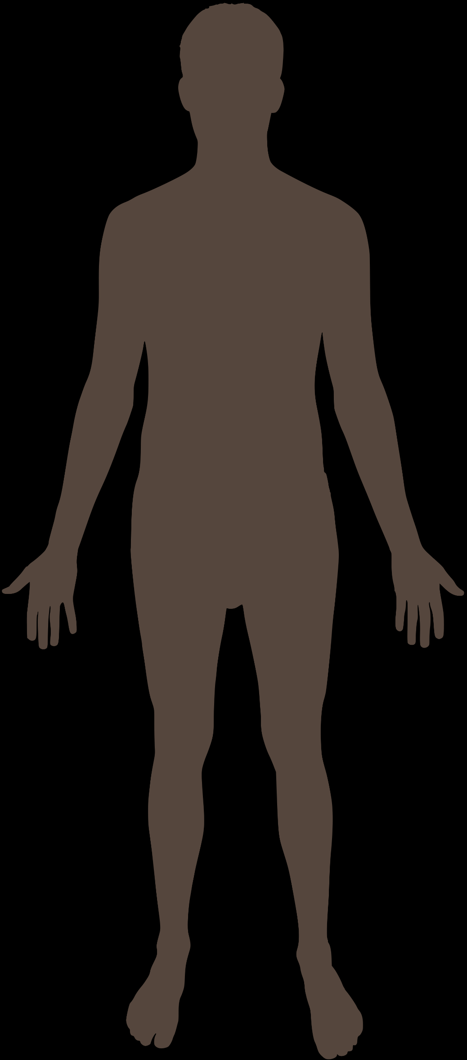
Body Scan (please select any symptoms you may have by ticking/selecting the appropriate box) (tick all that you have experienced to date and underline those that are relevant now
Head Mood
headaches☐migraine☐stiff neck ☐fuzzy headed☐dizziness☐ depressed☐anxious☐tense☐angry☐happy☐
poor balance☐pounding head☐feeling of hangover☐unexplained pain☐ balanced☐optimistic☐sad☐pessimistic☐
tired☐can’t be bothered☐hyperactive☐
Hair cheerful☐agitated☐easily upset☐tearful☐
oily ☐dry☐ poor condition☐brittle☐thinning☐ jittery☐frightened☐explosive☐pent up☐
Prematurely grey☐dandruff☐increased facial hair☐ irritated☐annoyed☐overwhelmed☐suicidal☐
increased body hair☐decreased body hair☐ fluctuating☐aggressive☐
Mouth Mind
Sore tongue☐white/red patches☐tooth decay☐ulcers☐ forgetful☐difficulty learning new things☐
bad breath☐sore throats☐poor sense of taste☐excess saliva☐ easily confused☐can’t switch off☐
dry mouth☐ difficulty swallowing☐hoarse voice☐gingivitis☐ difficulty concentrating☐easily frustrated☐
bleeding gums☐cold sores☐ easily distracted☐difficult to make decisions☐
loss of interest in daily life☐fogginess☐
Eyes dyslexia☐dyspraxia☐insomnia☐hyperactive
burning☐gritty☐protruding☐prone to infection☐sticky☐itchy☐ panic attacks☐no motivation☐
painful☐poor night vision☐dry☐cataracts☐sensitive to light☐
bags☐swollen eyelids☐blurred vision☐double vision☐ Chest
failing eyesight☐yellow sclera (white of eye)☐ frequent colds☐chest infections☐asthma☐
bronchitis☐palpitations☐heart condition☐
Ears chest discomfort/pain☐short of breath☐
blocked☐sore☐itchy☐weeping☐watering☐overly waxy☐ difficulty breathing☐wheezing☐
creased earlobe☐ persistent cough☐noisy breathing☐
breast pain☐
Nose
congested☐runny☐frequent nose bleeds☐prone to snoring☐ Gut
sinusitis☐hay fever☐post-nasal drip☐rhinitis☐sneezing☐ bloated☐painful☐tender☐cramping☐
poor sense of smell☐ distended☐nausea☐hiatus hernia☐
sensation of fullness☐acid reflux☐ heartburn☐
Muscles flatulence☐belching☐churning☐vomiting☐
tender☐pain☐cramps☐spasms☐twitches☐loss of tone☐ irritable bowel☐coeliac☐diverticula☐polyps☐
wasting☐weak☐stiff☐restless legs☐numbness☐ haemorrhoids☐ulcers☐sluggish☐sensitive☐
constipation☐diarrhoea☐
Skin
dry☐rough☐flaky☐scaly☐puffy☐pale☐brown patches☐ Genitals
change in moles/lesions☐congested☐oily☐clammy☐yellow☐ itchy☐thrush☐ulcers☐warts☐herpes☐
slow to heal☐acne☐pimples☐rosacea☐eczema☐dermatitis groin pain☐prostatitis☐
psoriasis☐rashes☐boils☐hives☐stretch marks☐cellulite☐ pelvic inflammatory disease☐impotence☐
easy bruising☐thread veins☐varicose veins☐ringworm☐ painful intercourse☐vaginal dryness☐
allergic reactions☐excessive sweating☐ painful or frequent urination☐
unexplained discharge☐
Joints
painful☐inflamed☐swollen☐stiff☐rheumatic☐arthritic☐ Hands
aching☐sore☐difficulty bending☐reduced mobility☐unsteadiness☐ dry☐cracked☐eczema☐pain in joints☐puffy☐
slow movement☐ chilblains☐numbness☐tingling☐feel clumsy☐
feel uncoordinated☐poor circulation☐
Nails
fragile☐dry☐brittle☐flaky☐peeling☐split☐fungal☐hangnails☐ legs and feet
infected☐split cuticles☐ridged☐spoon shaped☐ restless legs☐swollen☐aching☐athletes foot☐
white spots on more than 2☐horizontal white lines☐thickened☐ burning feet☐tender heels☐gout☐sciatica☐
dark nails☐pale nail bed☐ cold feet☐tingling☐numb☐prickling☐
Diet – please complete attached diet diary to the best of your ability (the more information I receive the better)

Are you currently following a medically prescribed diet (if so please give details)? Yes☐ No☐

Do you have any food allergies or intolerances?

Family history and health
Is there any history of physical or mental health problems, symptoms or disease in your family? If so, please give details.
Grandfathers:
Maternal:

Paternal:

Grandmothers:
Maternal:

Paternal:

Father:

Mother:

Siblings: (indicate ages and whether full or half blood relatives)

Children: (indicate ages)

Personal Health History
Starting with your most current health problems please list in the space provided, all significant health problems that you have encountered in your lifetime. Indicate where appropriate, the duration, timing and management of the health problem.
Health Problem e.g. depression, asthma, | Duration | Management e.g. antidepressant; citalopram, Ventolin and wheat free diet | Date i.e. 1980-current

Additional questions:
On average how much sleep do you get per night?

Do you have any history of eating disorders, substance abuse, high stress levels, psychiatric or neurological disorders that you have not yet mentioned? If so, please expand on these.

Do you have any difficulties maintaining dietary changes e.g. cravings, binging, emotional eating, loss of interest in food?

Is there anything else that you haven’t mentioned yet which you think would be useful for me to be aware of? (if so please describe)

* If you have been diagnosed or suspect you may have a medical condition, you should consult your GP for advice, diagnosis and treatment and always inform your health professional before starting any alternative or additional therapies, treatments or making any major changes in your diet or exercise programme.
*This questionnaire has been adapted from ION, CNM and CNELM documents.

